附件2：摘要模板

摘要题目（黑体小四）

作者1，作者2，作者3，作者*（楷体五号）
单位（楷体五号）

摘要内容xxxxxxxxxxxxxxxxxxxxxxxxxxxxxxxxxxxxxxxxxxxxxxxxxxxxxxxxxxxxxxxx xxxxxxxxxxxxxxxxxxxxxxxxxxxxxxxxxxxxxxxxxxxxxxxxxxxxxxxxxxxxxxxxxxxxxxxxxxxxxxxxxxxxxxxxxxxxxxxxxxxxxxxxxxxxxxxxxxxxxxxxxxxxxxxxxxxxxxxxxxxxxxxxxxxxxxxxx(宋体五号，times new roman 5号)
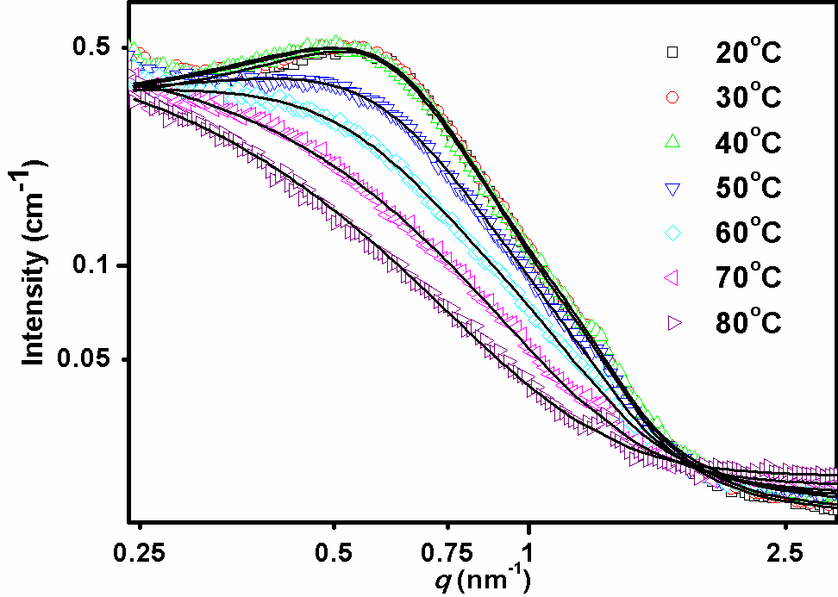
图1. xxxxxxxxxxx
摘要内容xxxxxxxxxxxxxxxxxxxxxxxxxxxxxxxxxxxxxxxxxxxxxxxxxxxxxxxxxxxxxxxx xxxxxxxxxxxxxxxxxxxxxxxxxxxxxxxxxxxxxxxxxxxxxxxxxxxxxxxxxxxxxxxxxxxxxxxxxxxxxxxxxxxxxxxxxxxxxxxxxxxxxxxxxxxxxxxxxxxxxxxxxxxxxxxxxxxxxxxxxxxxxxxxxxxxxxxxx(宋体五号，times new roman 5号)

关键词：xx；xx；xx；xx；xx；xx (宋体5号)

参考文献（五号）：
[1] I. Breßler, J. Kohlbrecher, A.F. Thünemann, SASfit: A tool for small-angle scattering data analysis using a library of analytical expressions, J. Appl. Cryst. 48 (2015) 1587–1598.

